TITLE
First Author Full Name^{1*},……
¹ Department/Affiliation, Institution/University, City, Country
*Corresponding Author Email | Telephone
Topic: [Select a Topic]
Abstract
Insert your abstract text here (maximum 250 words). The abstract should provide a concise summary of the research, including the objective, methodology, key findings, and main conclusions. Ensure the text is formatted using Times New Roman, 12 pt font, with justified alignment and 1.15 line spacing.
Keywords: Keyword 1, Keyword 2, Keyword 3, Keyword 4, Keyword 5 (Maximum 5 keywords).
Figures and Illustrations
Authors are encouraged to include original, high-resolution visual materials such as schematic diagrams, graphic illustrations, data plots, and testing flowcharts to support their abstract. All figures should be accompanied by a concise caption and sequentially numbered.
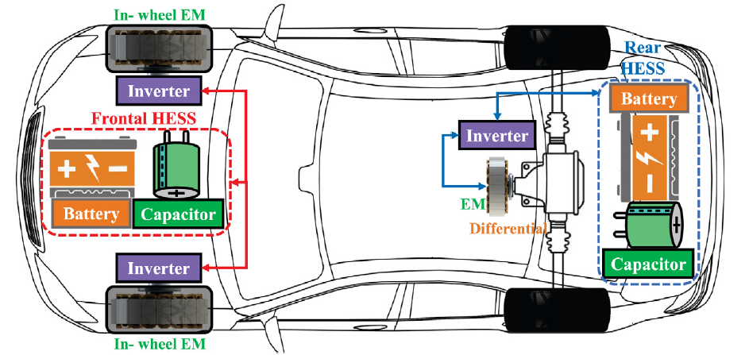
Figure 1. Dual HESS electric vehicle powertrain design and fuzzy control based on multi-objective optimization to increase driving range and battery life cycle [1].

References (Optional)
- S. F. da Silva, J. J. Eckert, F. C. Corrêa, F. L. Silva, L. C. A. Silva and F. G. Dedini, 2022.“Dual HESS electric vehicle powertrain design and fuzzy control based on multi-objective optimization to increase driving range and battery life cycle”, J Appl Energy: Vol 324, 119723.

